Master of Ceremonies Bio – Kayode Malomo
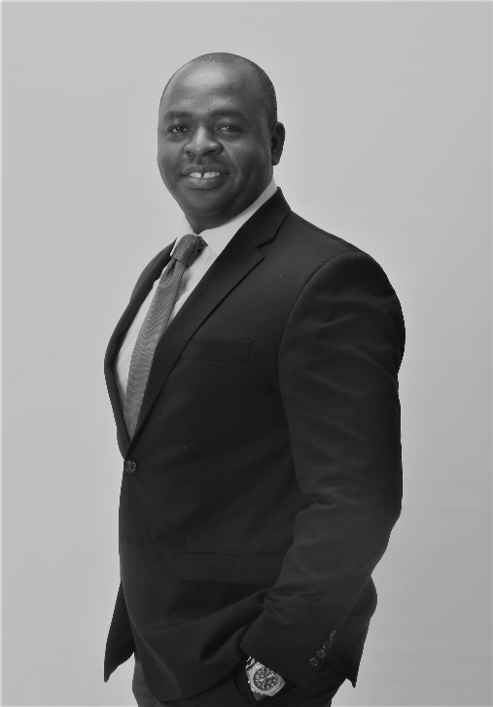
Kayode Malomo or “ Kayo” is an accomplished Master of Ceremonies, entrepreneur, artist, and community leader known for bringing energy, professionalism, and authenticity to every event he hosts. With a natural ability to connect with diverse audiences, Kayode creates an engaging atmosphere that keeps programs flowing seamlessly while ensuring every guest feels welcomed and valued.
Drawing from years of leadership in business, nonprofit service, and the arts, Kayode brings a unique blend of warmth, humor, and poise to the stage.
Kayode MC’s weddings, corporate conferences, birthdays, fundraising galas, awards ceremonies, cultural celebrations, faith-based gatherings and community events.
He has a remarkable talent for balancing elegance with enthusiasm. Kayode started his career as a child actor on TV soap opera, Tales By Moonlight in West Africa.
As the founder of Maximize Potential Group, Kayode is passionate about inspiring hope, empowering communities, and creating opportunities for those in need. His commitment to service is reflected in his hosting style—professional, personable, and purpose-driven.
In addition to his work as an MC, Kayode is an internationally recognized creative artist whose work celebrates culture, resilience, and human connection. His creative background enhances his ability to tell compelling stories, engage audiences, and create memorable event experiences.
Known for his meticulous preparation, humor, strong stage presence, and ability to adapt effortlessly to any audience, Kayode Malomo is a trusted host who transforms events into unforgettable experiences. Whether introducing distinguished guests, facilitating panel discussions, or keeping celebrations on schedule, he delivers every program with confidence, excellence, and a genuine passion for people.

